
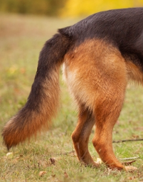
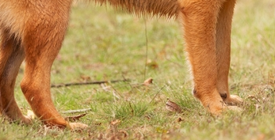

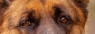

Face = eyes*0.2 + nose*0.2+ears*0.5
Sample Scores 1,2,3==0.8,0.9,0.6
==> 0.8*0.2+0.9*0.2+0.6*0.5 = 0.79

Body : face*0.6 + body*0.4
15
12
11
5
4
3
2
1

